**Object Oriented Programming**

**CP Task 04**

Name : Umair Abbas

Registration #: L1F19BSCS0442

Section: D

Answer the following questions based on given class relationship:

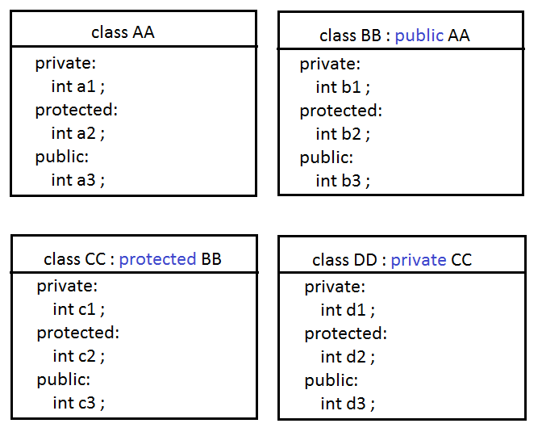

**Question 01:**

Which type of Inheritance hierarchy is implemented in above given scenario?

(single level, multi-level, multiple OR hybrid)

**Answer: Multi-Level Inheritance hierarchy is implemented in above given scenario.**

**Question 02:**

Draw class diagram (UML diagram) for this scenario using any drawing tool and submit PNG or JPG file.

*You can use* ***MS Visio*** *or* ***draw.io*** *(*[*https://app.diagrams.net/*](https://app.diagrams.net/) *) or even* ***PAINT*** *for this task.*

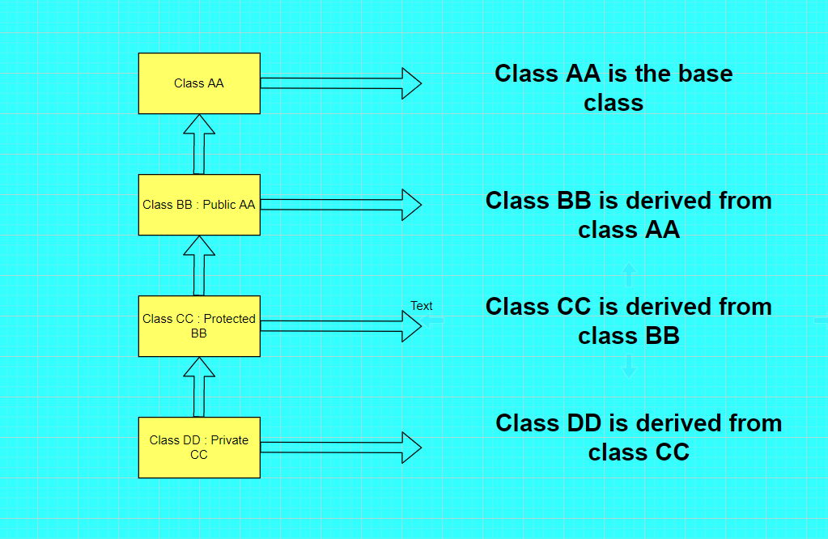

**Question 03:**

Implement the scenario in C++ (using multiple files). Submit all header and CPP files along with this WORD file.

**Questions 04:**

Based on your code, fill the table given below:

|  |  |
| --- | --- |
|  | **Access**  *(private, protected, public, inaccessible)* |
| Access of a1 inside class BB | Inaccessible |
| Access of a1 inside class CC | Inaccessible |
| Access of a1 inside class DD | Inaccessible |
| Access of a2 inside class BB | Protected |
| Access of a2 inside class CC | Protected |
| Access of a2 inside class DD | Protected |
| Access of a3 inside class BB | Public |
| Access of a3 inside class CC | Public |
| Access of a3 inside class DD | Public |
| Access of b1 inside class CC | Inaccessible |
| Access of b1 inside class DD | Inaccessible |
| Access of b2 inside class CC | Protected |
| Access of b2 inside class DD | Protected |
| Access of b3 inside class CC | Public |
| Access of b3 inside class DD | Public |
| Access of c1 inside class DD | Inaccessible |
| Access of c2 inside class DD | Protected |
| Access of c3 inside class DD | Public |
| **Statement in main()** | **Access**  *(accessible OR inaccessible)* |
| objectOfAA.a1 ; | Inaccessible |
| objectOfAA.a2 ; | Inaccessible |
| objectOfAA.a3 ; | Accessible |
|  |  |
| objectOfBB.a1 ; | Inaccessible |
| objectOfBB.a2 ; | Inaccessible |
| objectOfBB.a3 ; | Accessible |
| objectOfBB.b1 ; | Inaccessible |
| objectOfBB.b2 ; | Inaccessible |
| objectOfBB.b3 ; | Accessible |
|  |  |
| objectOfCC.a1 ; | inaccessible |
| objectOfCC.a2 ; | inaccessible |
| objectOfCC.a3 ; | inaccessible |
| objectOfCC.b1 ; | inaccessible |
| objectOfCC.b2 ; | inaccessible |
| objectOfCC.b3 ; | inaccessible |
| objectOfCC.c1 ; | inaccessible |
| objectOfCC.c2 ; | inaccessible |
| objectOfCC.c3 ; | Accessible |
|  |  |
| objectOfDD.a1 ; | Inaccessible |
| objectOfDD.a2 ; | Inaccessible |
| objectOfDD.a3 ; | inaccessible |
| objectOfDD.b1 ; | Inaccessible |
| objectOfDD.b2 ; | Inaccessible |
| objectOfDD.b3 ; | Inaccessible |
| objectOfDD.c1 ; | Inaccessible |
| objectOfDD.c2 ; | Inaccessible |
| objectOfDD.c3 ; | Inaccessible |
| objectOfDD.d1 ; | Inaccessible |
| objectOfDD.d2 ; | Inaccessible |
| objectOfDD.d3 ; | accessible |